**Importing the KPITarget Table**

1. Download the KPITarget Excel file containing the data for KPITarget Table.
2. Open SQL Server Management Studio (SSMS).
3. Connect to the Database Engine.
4. Import Data.
   1. Navigate to Contoso_MSCRM → Tasks → Import Data.

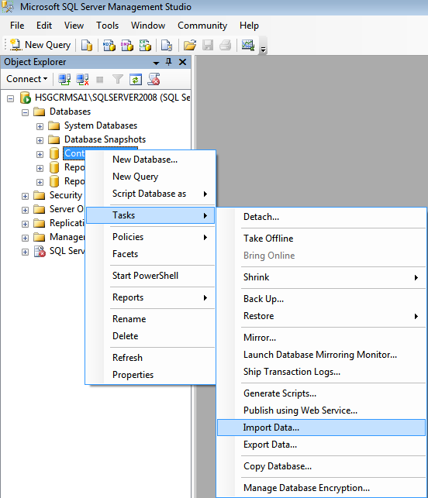

* 1. Select the Data source: Microsoft Excel.
  2. Locate the KPITarget Excel file.
  3. Select Excel version: Microsoft Excel 97-2003.
  4. Check the box for First row has column names.
  5. Click Next.

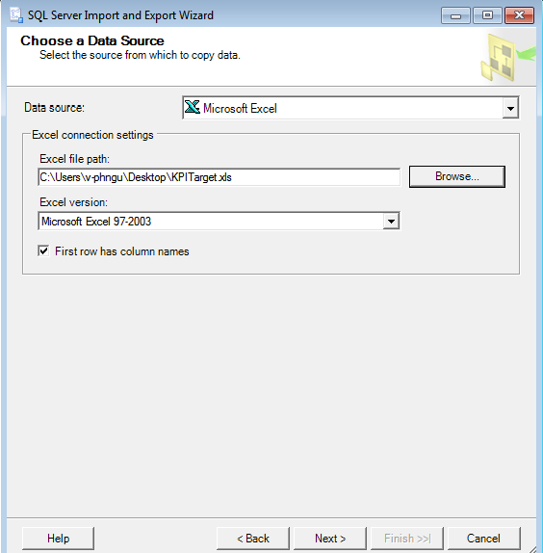

* 1. Select Destination: SQL Server Native Client 10.0.
  2. Select the appropriate Server name.
  3. Select Authentication: Use Windows Authentication.
  4. Select Database: Contoso_MSCRM.
  5. Click Next.

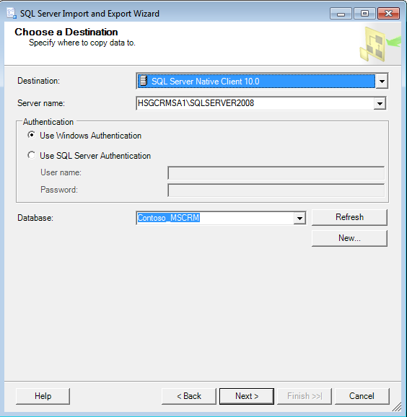

* 1. Select Copy data from one or more tables or views.
  2. Click Next.

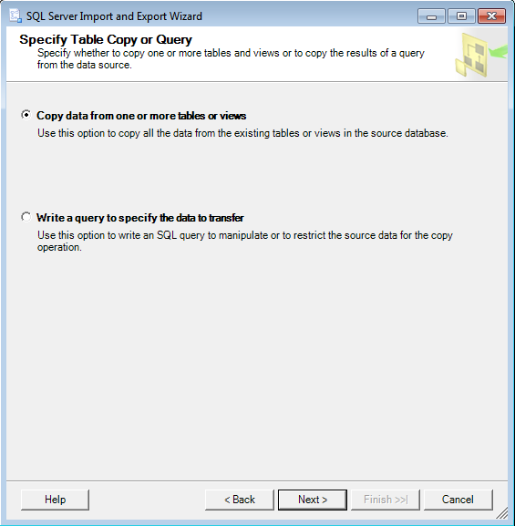

* 1. Select Sheet 1.
  2. Rename the Destination Table to [dbo].[KPITarget].
  3. Click Next and Finish on the resultant screens.

